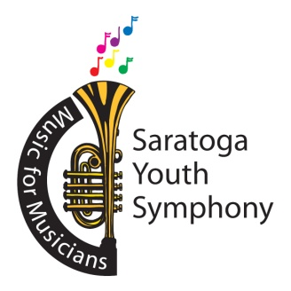
Joshua Thompson, Music Director
Sue Nazzaro, Executive Director
Ellen Madison, Marketing Director

Saratoga Youth Symphony T-Shirt Order Form

Choose Sizes and quantities below:

All T-Shirts are $ 15 each

Short Sleeve T-Shirt – ADULT SMALL Quantity: _____
Short Sleeve T- Shirt – ADULT MEDIUM Quantity: _____
Short Sleeve T-Shirt – ADULT LARGE Quantity: _____
Short Sleeve T-Shirt – ADULT XL Quantity: _____
Short Sleeve T-Shirt – ADULT XXL Quantity: _____

Name: _______________________________
Telephone Number: ______________________
Total Amount enclosed: _______
Checks should be payable to the: Saratoga Youth Symphony

Order form and checks can either be mailed to the SYS at:
P.O. Box 3092, Saratoga Springs, NY 12866
or, handed to Sue Nazzaro at a rehearsal.

