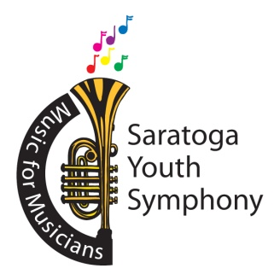
Joshua Thompson, Music Director
Sue Nazzaro, Executive Director
Ellen Madison, Marketing Director

Emergency Contact - First Aid/Emergency Treatment Authorization

Student Name: _________________________________Date of Birth: _______________
Name of Parent(s) /Guardian(s): _
Home phone: Cell phone: Email address:
List any information that you would like us to know: Ex: ailments/allergies/medications
_____________________________________________________________________
If we cannot contact either parent or guardian, please list two relatives or friends who would have the authority to advise us regarding your child:
Name __________________ Relationship to student ____________Phone _____________
Name __________________ Relationship to student ____________Phone _____________
If none of the above can be reached by phone, please indicate WHAT YOU WANT US TO DO in case your child is sick or injured:
□ __________________________________(please fill in blank)

□ Take to nearest hospital
If EMERGENCY TREATMENT is required, the responsible parties of the Saratoga Youth Symphony have my permission to use their own judgment in seeking the most expedient professional care for my child. □ Yes □ No
It is understood that the final disposition of any emergency will be the judgment of the responsible adults of the Saratoga Youth Symphony, with regard to the fullest possible extent to the recommendations of the parent/guardian stated above.
____________________________________________________________________
Signature of Parent/Guardian Date

